Chapter 13, Problem 49.

Find current i_{x} in the ideal transformer circuit shown in Fig. 13.113.

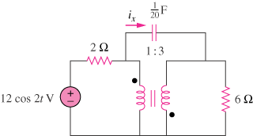

Figure 13.113
For Prob. 13.49.

